Taking Turns in Games Social Situation

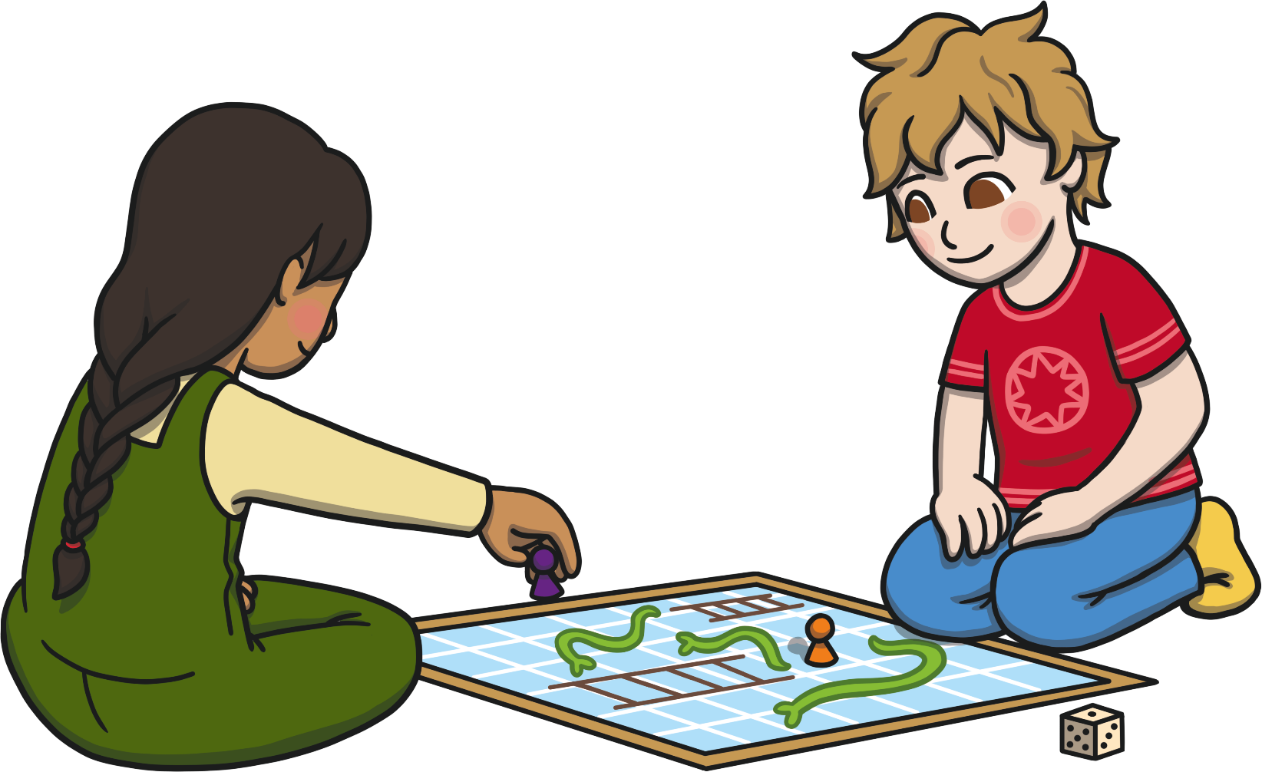

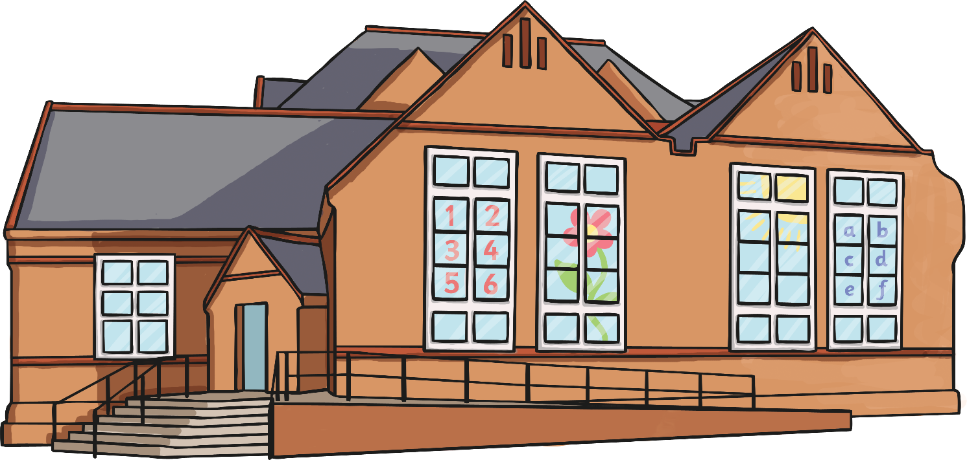

My name is .
My teacher is .
I go to school.

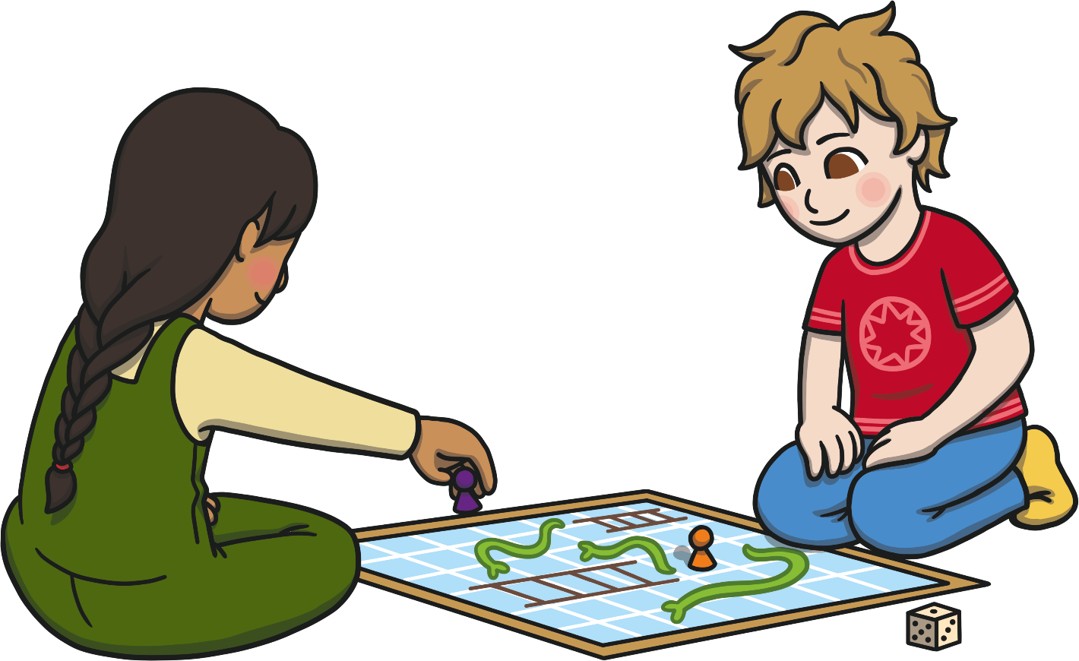
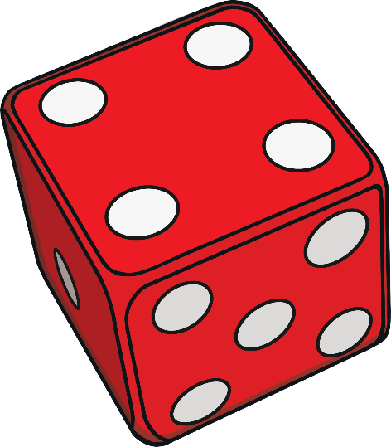
I like playing games with my friends.
In my class, we sometimes play games in small groups.
Some of the games we play need the players to roll the dice.
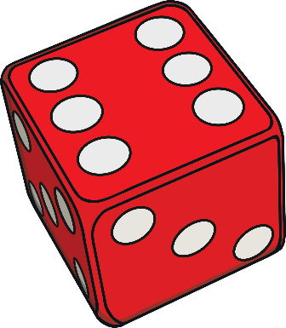
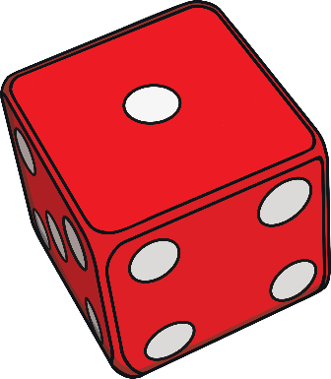
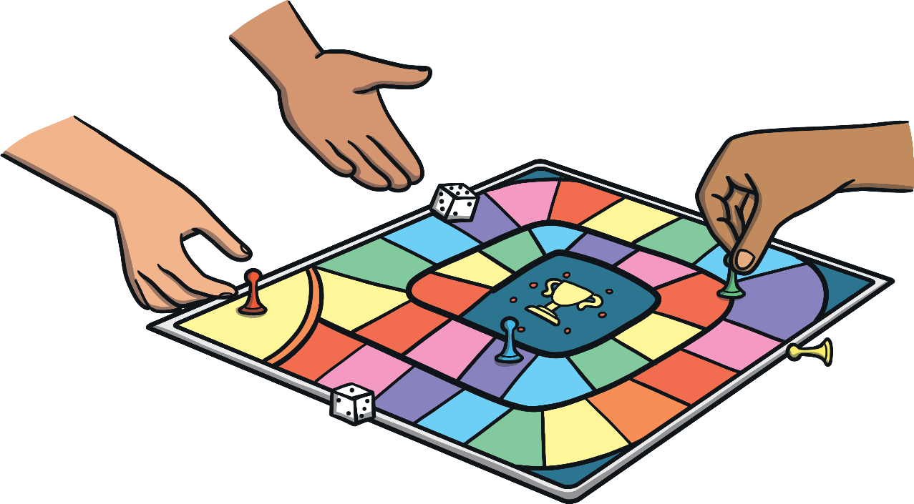
When the dice is rolled, it will land on a number.
This could be a low number, like one or a high number, like six.
I like to roll high numbers so that I can win the game. When I roll a low number, like one, it can make me sad.
I will try to remember that I will have another go at rolling the dice and that I won’t always win the game. It is nice for my friends to win the game too!
When I play board games, I must remember to wait until it is my turn to roll the dice. Sometimes, waiting is difficult but taking turns means we all have a go at rolling the dice. Everyone that plays the game has to wait and take turns.

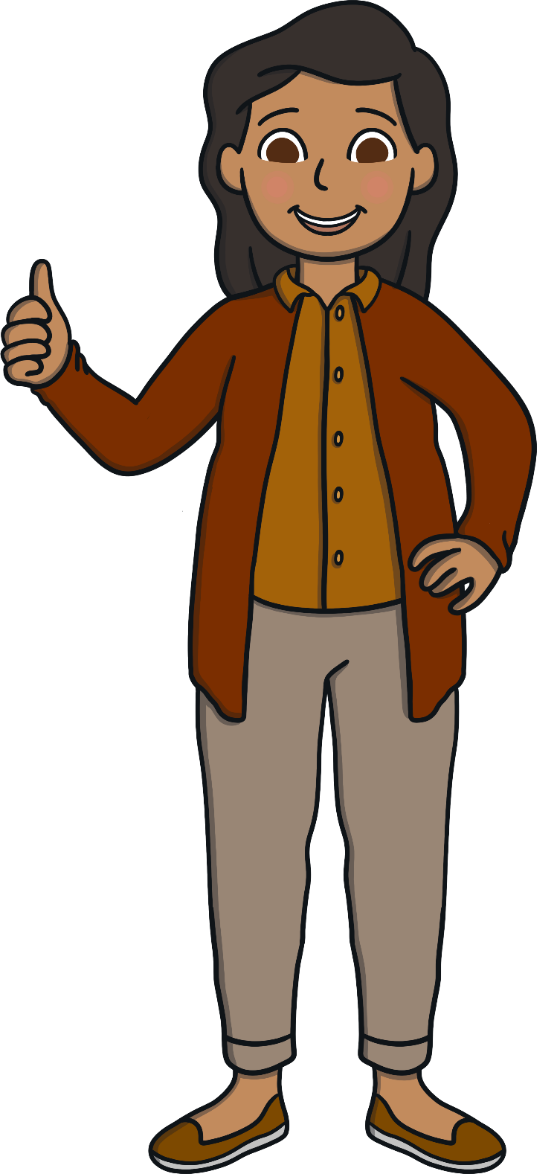
Playing games with a dice can be difficult. I will try to remember to wait my turn to roll the dice and that it is OK to roll a low number because there will be other turns and other games that I could win.

